CA -3

DevOps Automation
Submitted by:
Nandana S
12317635
K23DV - A - 07

B-Tech CSE DevOps
GitHub Link: https://github.com/nandanaShaji77/CA-3-DevOps-Automation.git



Task 1: Automated Triggering via ngrok

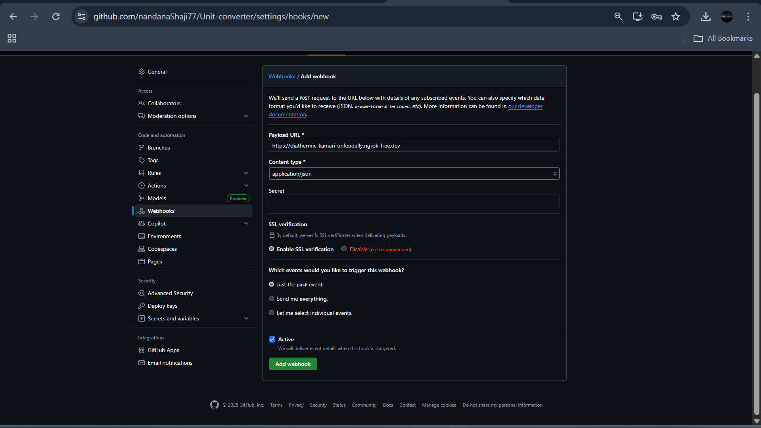
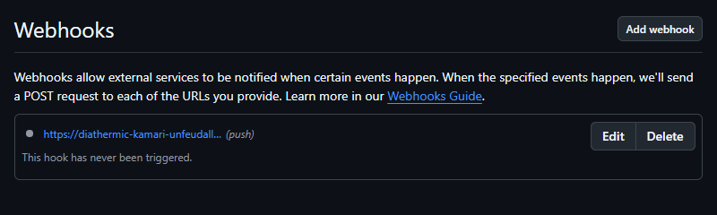
Webhook successfully created with the help of ngrok
“ngrok http 8080”

Task 2: Pipeline Environment & Credentials

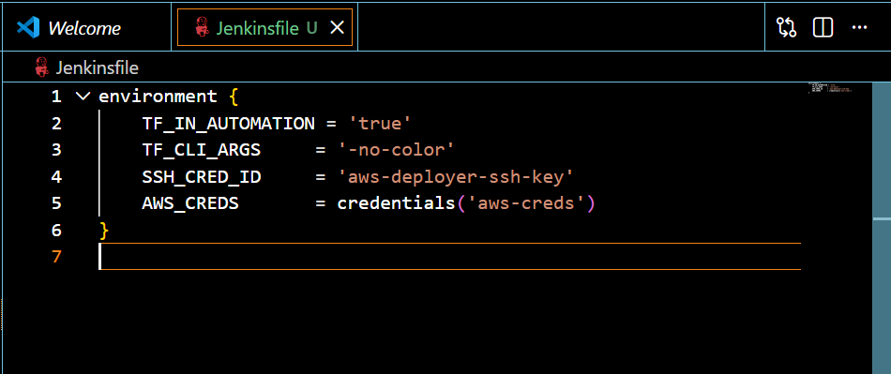
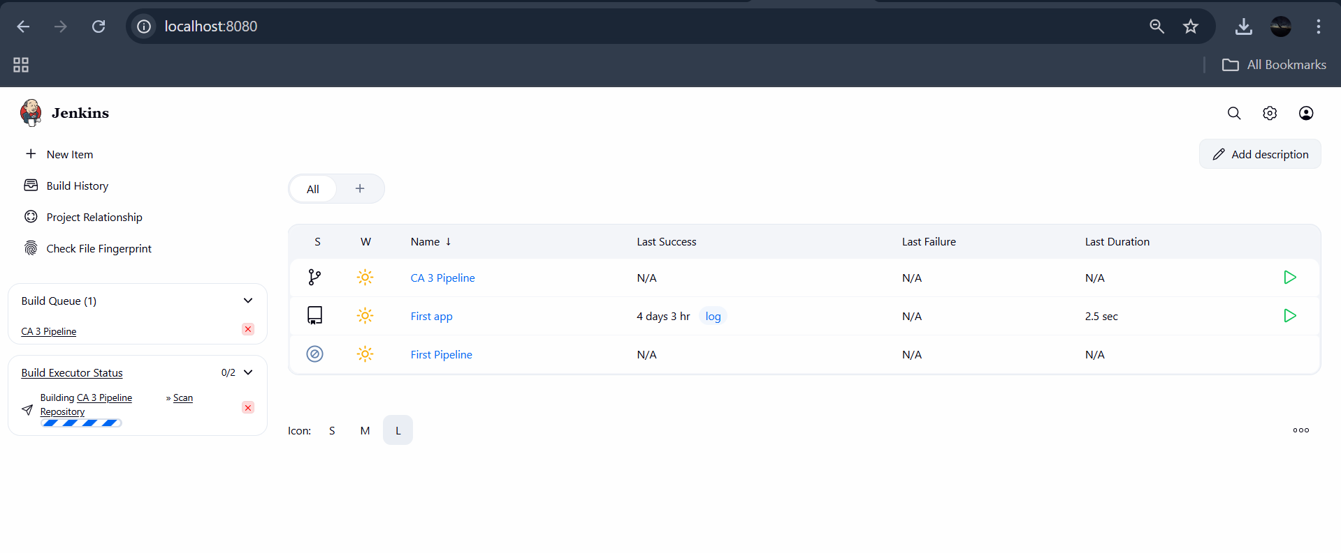
Jenkins running on ‘http://localhost:8080/’
‘CA 3 Pipeline’ is the new multibranch pipeline created for the BYOD

Task 3: Initialization and variable inspection

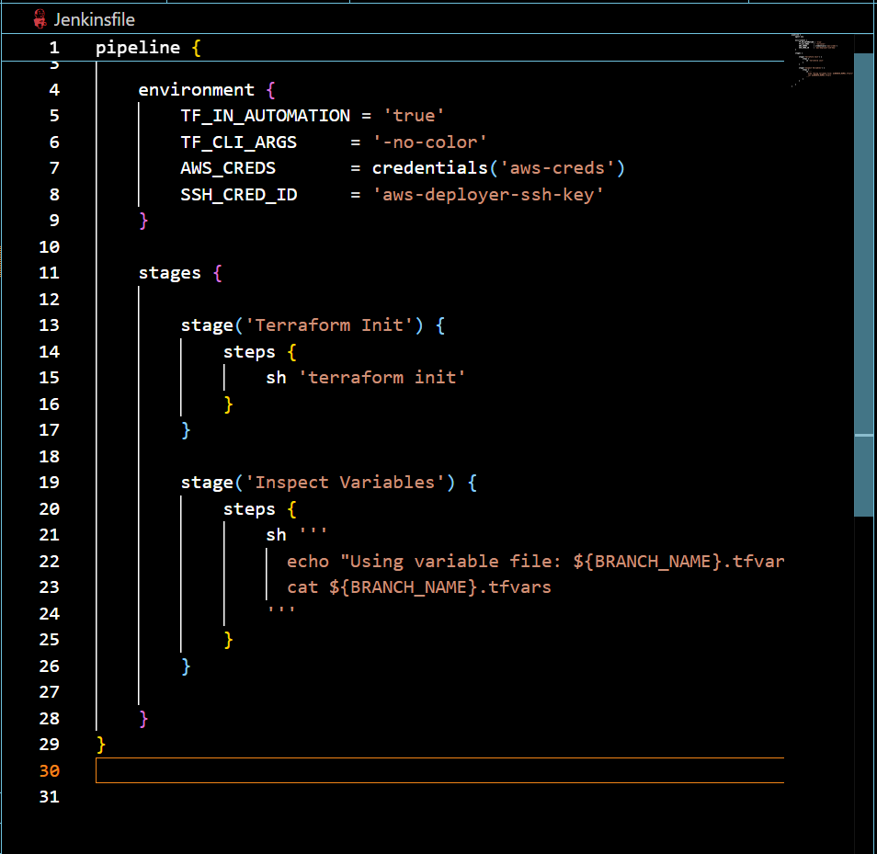
Task 4: Branch-Specific Terraform Planning

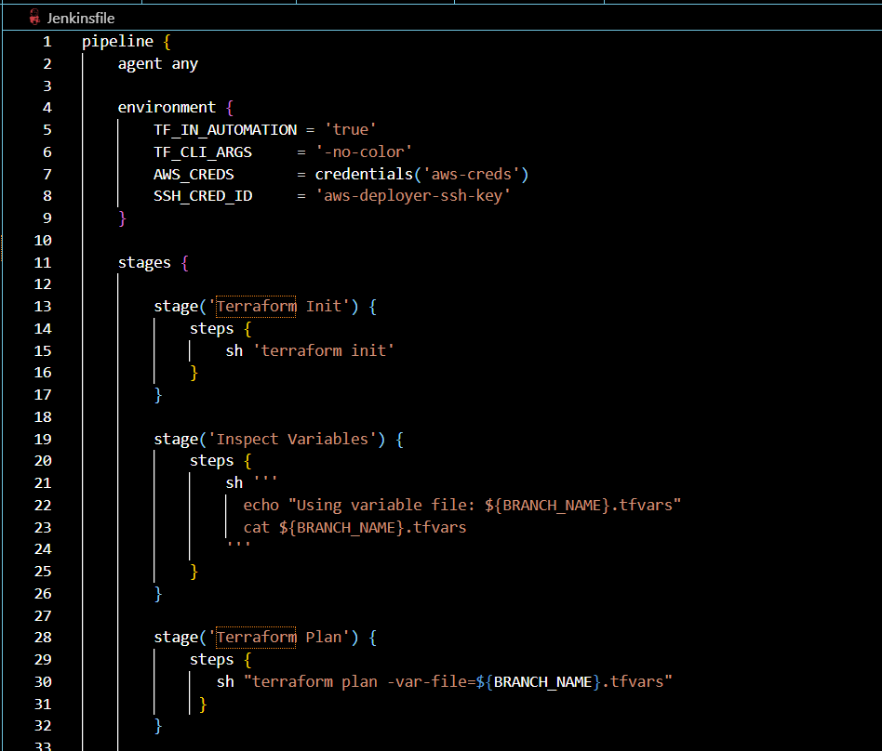

Task 5: Conditional Manual Approval Gate

